Jen’s Very Simple Poppy Pattern

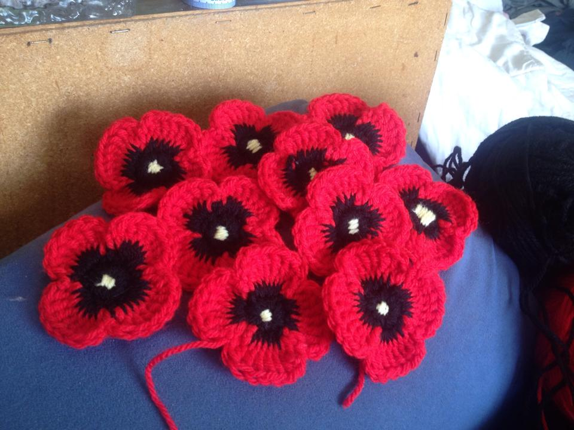

Sl: slip stitch
Ch: chain
Tr: Treble/triple crochet
Using first colour (black)
Beginning ch4, join with a slip stitch to the first chain to form a ring.
Round 1: 12 sc in ring, join with sl to first sc and fasten off.
Change colour (red)
Round 2: Insert hook into sl of last round, pull up a loop and ch5, skip two stitches and sl into the next st ch5, *repeat around completing the last ch5 set in the same space as the first with a sl (At the end of the round, you will have 4 sets of ch5)
Round 3: *Tr 8 times in the ch5 space of the previous round, ch1 and sl to the joining sl of the previous round, *repeat around the remaining three ch5 spaces. Fasten off
Sew in ends.

